
Practice Education Learning Partnership (PELP)
Connect, Reflect & Learn
CPD ‘bite size’ series for Practice Educators and Placement Supervisors

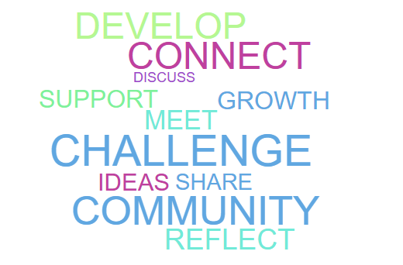

When: 21st May 2026 at 10.00-11.30
Where: online – teams (please book via Eventbrite)
Topic – SMART PLANNING

We are hosting a series of CPD events through the Practice Educator Learning Partnership (PELP). This free event is for practice educators or supervisors supporting pre-qualifying social work students.

This event focuses on:
SMART in Theory, Smarter in Action will be an interactive online session designed to support practice educators to strengthen the quality of planning with learners. The session will focus on the practical application of SMART principles and will explore why weak or overly broad Professional Development Plan (PDP) objectives can undermine learning and assessment, drawing on real practice examples and moderation feedback.
Through a blend of taught input, reflective discussion and hands-on activities, participants will build confidence in translating feedback from supervision, observation and reviews into clear, achievable and meaningful SMART objectives.
The session will emphasise the use of PDPs as live developmental tools that support learning, confidence and fair assessment, rather than as compliance-driven paperwork, across student, ASYE and wider professional development pathways.
By the end of the session, participants will be able to:
- explain why weak or poorly constructed PDP objectives can undermine learning and assessment
- identify common issues in PDPs, such as vague language, “ongoing” goals and overloaded plans
- apply SMART principles to rewrite broad or generic objectives into focused, achievable PDP goals
- translate feedback from observation, supervision and reviews into SMART PDP objectives
- support learners to use PDPs as active developmental tools rather than compliance documents
The second part of the session is an opportunity for you to share reflections in smaller peer groups.

On behalf of the Practice Educator Learning Partnership (PELP) and the Pan Dorset and Wiltshire Teaching Partnership we look forward to welcoming you!

